A REPORT
on
Hospital Training - II

Submitted in Partial Fulfillment of the requirements For the Degree of
Bachelor of Pharmacy
By

Himanshu Kumar

B.Pharm. III Year, V Semester Roll No.:2110180500035
Ambekeshwar Institute of Pharmaceutical Sciences (Lucknow)



Under the Supervision of
SUPERVISOR
Prof (Dr.) Savita Upadhyay Director (Pharmacy)
AIPS, Lucknow

CO-SUPERVISOR
Dr. Ila Dixit
Assistant Professor AIPS, Lucknow

to the
Faculty of Pharmacy
Dr. A.P.J. Abdul Kalam Technical University, Lucknow 2023-2024



CERTIFICATE OF COMPILATION

This is to certify that this project report entitled “Hospital Training - I” submitted to Ambekeshwar Institute of Pharmaceutical Sciences, Lucknow, is a bonafide record of work done by Himanshu Kumar (Roll No.:2110180500035) during the period of his/her study in Bachelor of Pharmacy in the academic year 2023-2024 in the Fifth semester of Third Year.

SUPERVISOR
Prof (Dr.) Savita Upadhyay Director (Pharmacy)
AIPS, Lucknow
CO-SUPERVISOR
Dr. Ila Dixit
Assistant Professor
AIPS, Lucknow

EXTERNAL EXAMINER

DATE: ……………………

COPYRIGHT

Declaration by the Candidate

I hereby declare that the Ambekeshwar Institute of Pharmaceutical Sciences, Lucknow shall have the rights to preserve, use and disseminate the report in print or electronic format for academic/ research purpose.

Place: Lucknow Himanshu Kumar
Date: Roll No.: 2110180500035

DECLARATION BY THE CANDIDATE

This is to certify that the work presented in the report entitled “Hospital Training - I” has been carried out by me for the partial fulfillment of degree of ‘Bachelor of Pharmacy’ under the supervision of Prof (Dr.) Savita Upadhyay and Co-supervision of Dr. Ila Dixit of Ambekeshwar Institute of Pharmaceutical Sciences, Lucknow.
The report embodies results of the original work and studies carried out by me and the contents of the report have not formed the basis for the award of any degree/ diploma by any other University or Institution.
I also confirm that all the material which I have borrowed from other sources and incorporated in this report is duly acknowledged.

Place: Lucknow Himanshu Kumar
Date: Roll No.: 2110180500035

CERTIFICATE BY THE CO-SUPERVISOR

This is to certify that the work presented in the report entitled “Hospital Training - I” submitted by Himanshu Kumar (Roll No.:2110180500035) for the degree of ‘Bachelor of Pharmacy’ has been carried out in the Ambekeshwar Institute of Pharmaceutical Sciences, Lucknow under my guidance.

Place: Lucknow

Date:
Dr. Ila Dixit
Assistant Professor AIPS, Lucknow

CERTIFICATE BY THE SUPERVISOR

This is to certify that the work presented in the report entitled “Hospital Training - I” submitted by Himanshu Kumar (Roll No.:2110180500035) for the degree of ‘Bachelor of Pharmacy’ has been carried out in the Ambekeshwar Institute of Pharmaceutical Sciences, Lucknow under the co-supervision of Dr. Ila Dixit, Assistant Professor, Ambekeshwar Institute of Pharmaceutical Sciences, Lucknow.

Place: Lucknow

Date:
Prof (Dr.) Savita Upadhyay
Director (Pharmacy) AIPS, Lucknow

Acknowledgement

I am very entitled for being associated with RAM SAGAR MISHRA 100 BEDDED COMBINED HOSPITAL, BKT LUCKNOW. It is highly professionalized hospital that give professional quality of treatment, by increasing training or raising required qualification and it is full of modernity with modernity. I have learned a lot during my training duration of 45 days and contain has been fortunate in getting an opportunity of working in this hospital.
I would like to thanks MR. RAJESH JHA, providing necessary training facilities and guidance during entire period of my training.
I would like to thanks all trainees and staff, who help me very much and without whom support and guidance it was impossible for me to complete the project successfully.
I would like to express my gratitude towards my parents and member of Ambekeshwar Institute of Pharmaceutical sciences for their kind co-operation and encouragement which help me in completion of this project.

Place: Lucknow
Date:
Himanshu Kumar

List of Tables
Table no.1-Normal WBCs 12
Table no.2-List of medicines 16

List of Figures
Figure no.1 Hospital 1
Figure no.2 Emergency room 4
Figure no.3 General ward 6
Figure no.4 Injection room 7
Figure no.5 Types of injection 9
Figure no.6 Pathology 10
Figure no.7 Diagnostic report 11
Figure no.8 Dispensary 15

List of Abbreviations

S no. | Name | Full form
1 | ICU | Intensive care unit
2 | OPD | Outpatient department
3 | ED | Emergency room
4 | CPR | Cardio pulmonary resuscitation
5 | IV | Intravenous
6 | IM | Intramuscular
7 | CBC | Complete blood count
8 | WBC | White blood cells
9 | RBC | Red blood cells
10 | MRI | Magnetic resonance imaging
11 | CT | Computed tomography

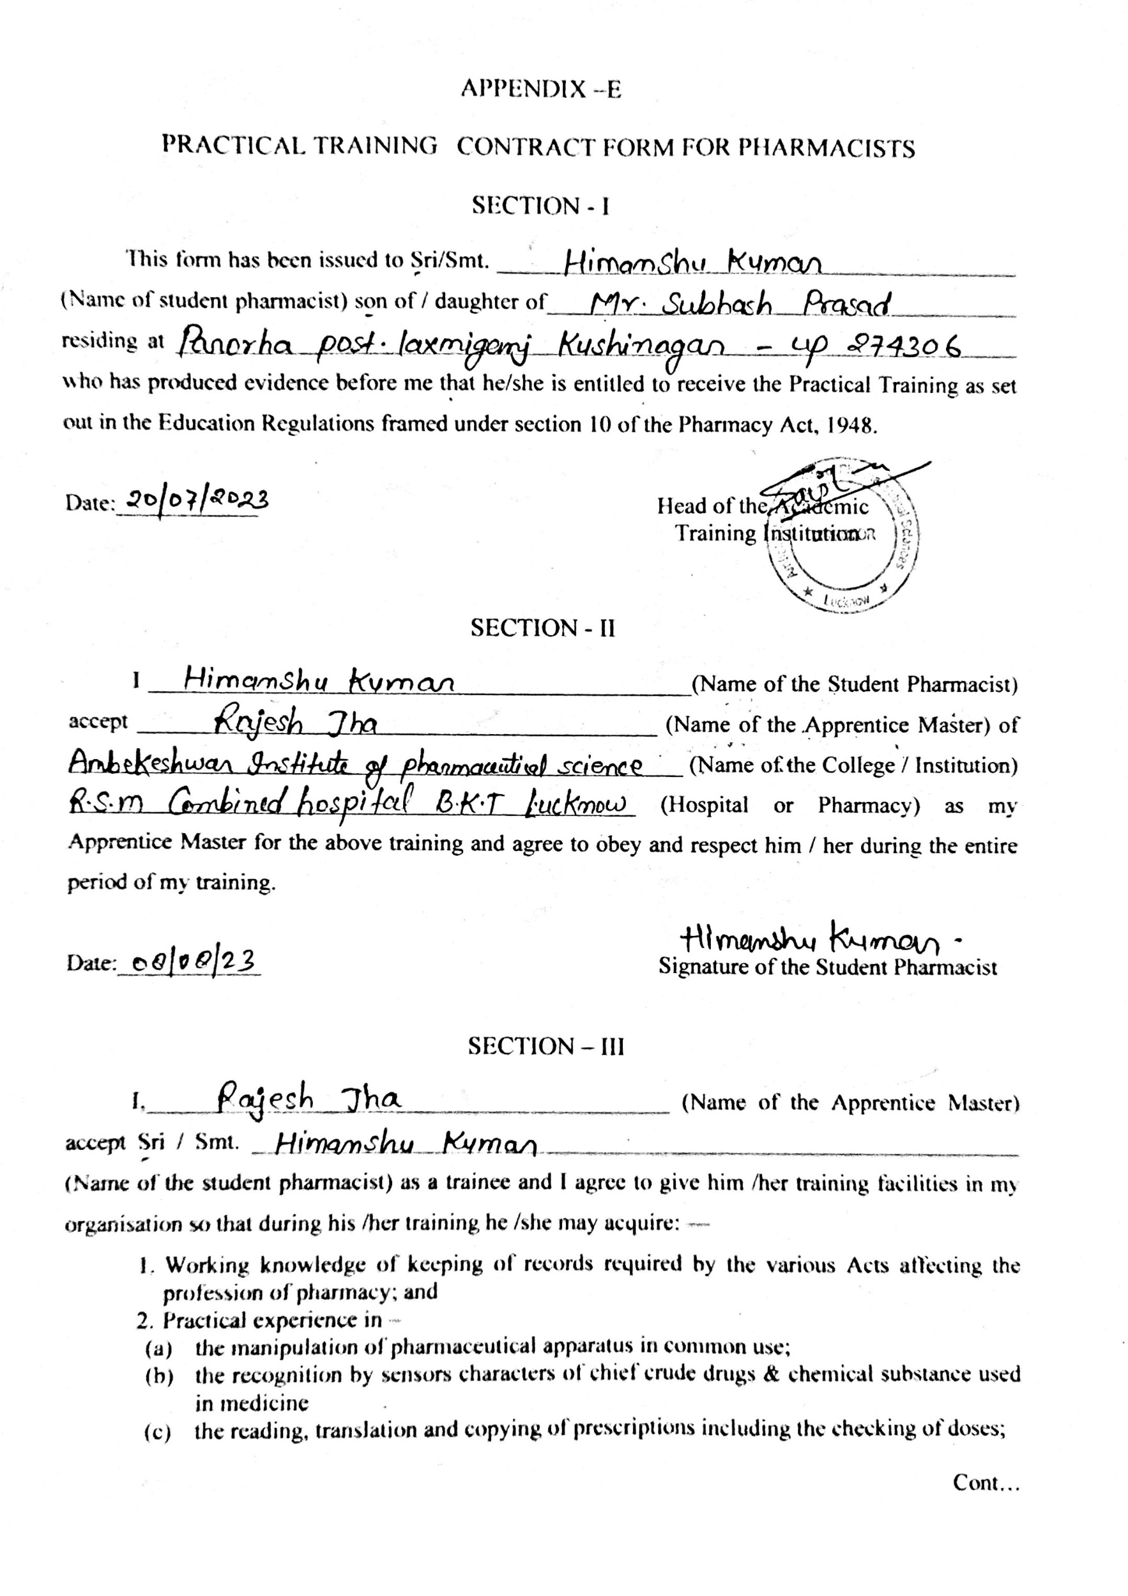

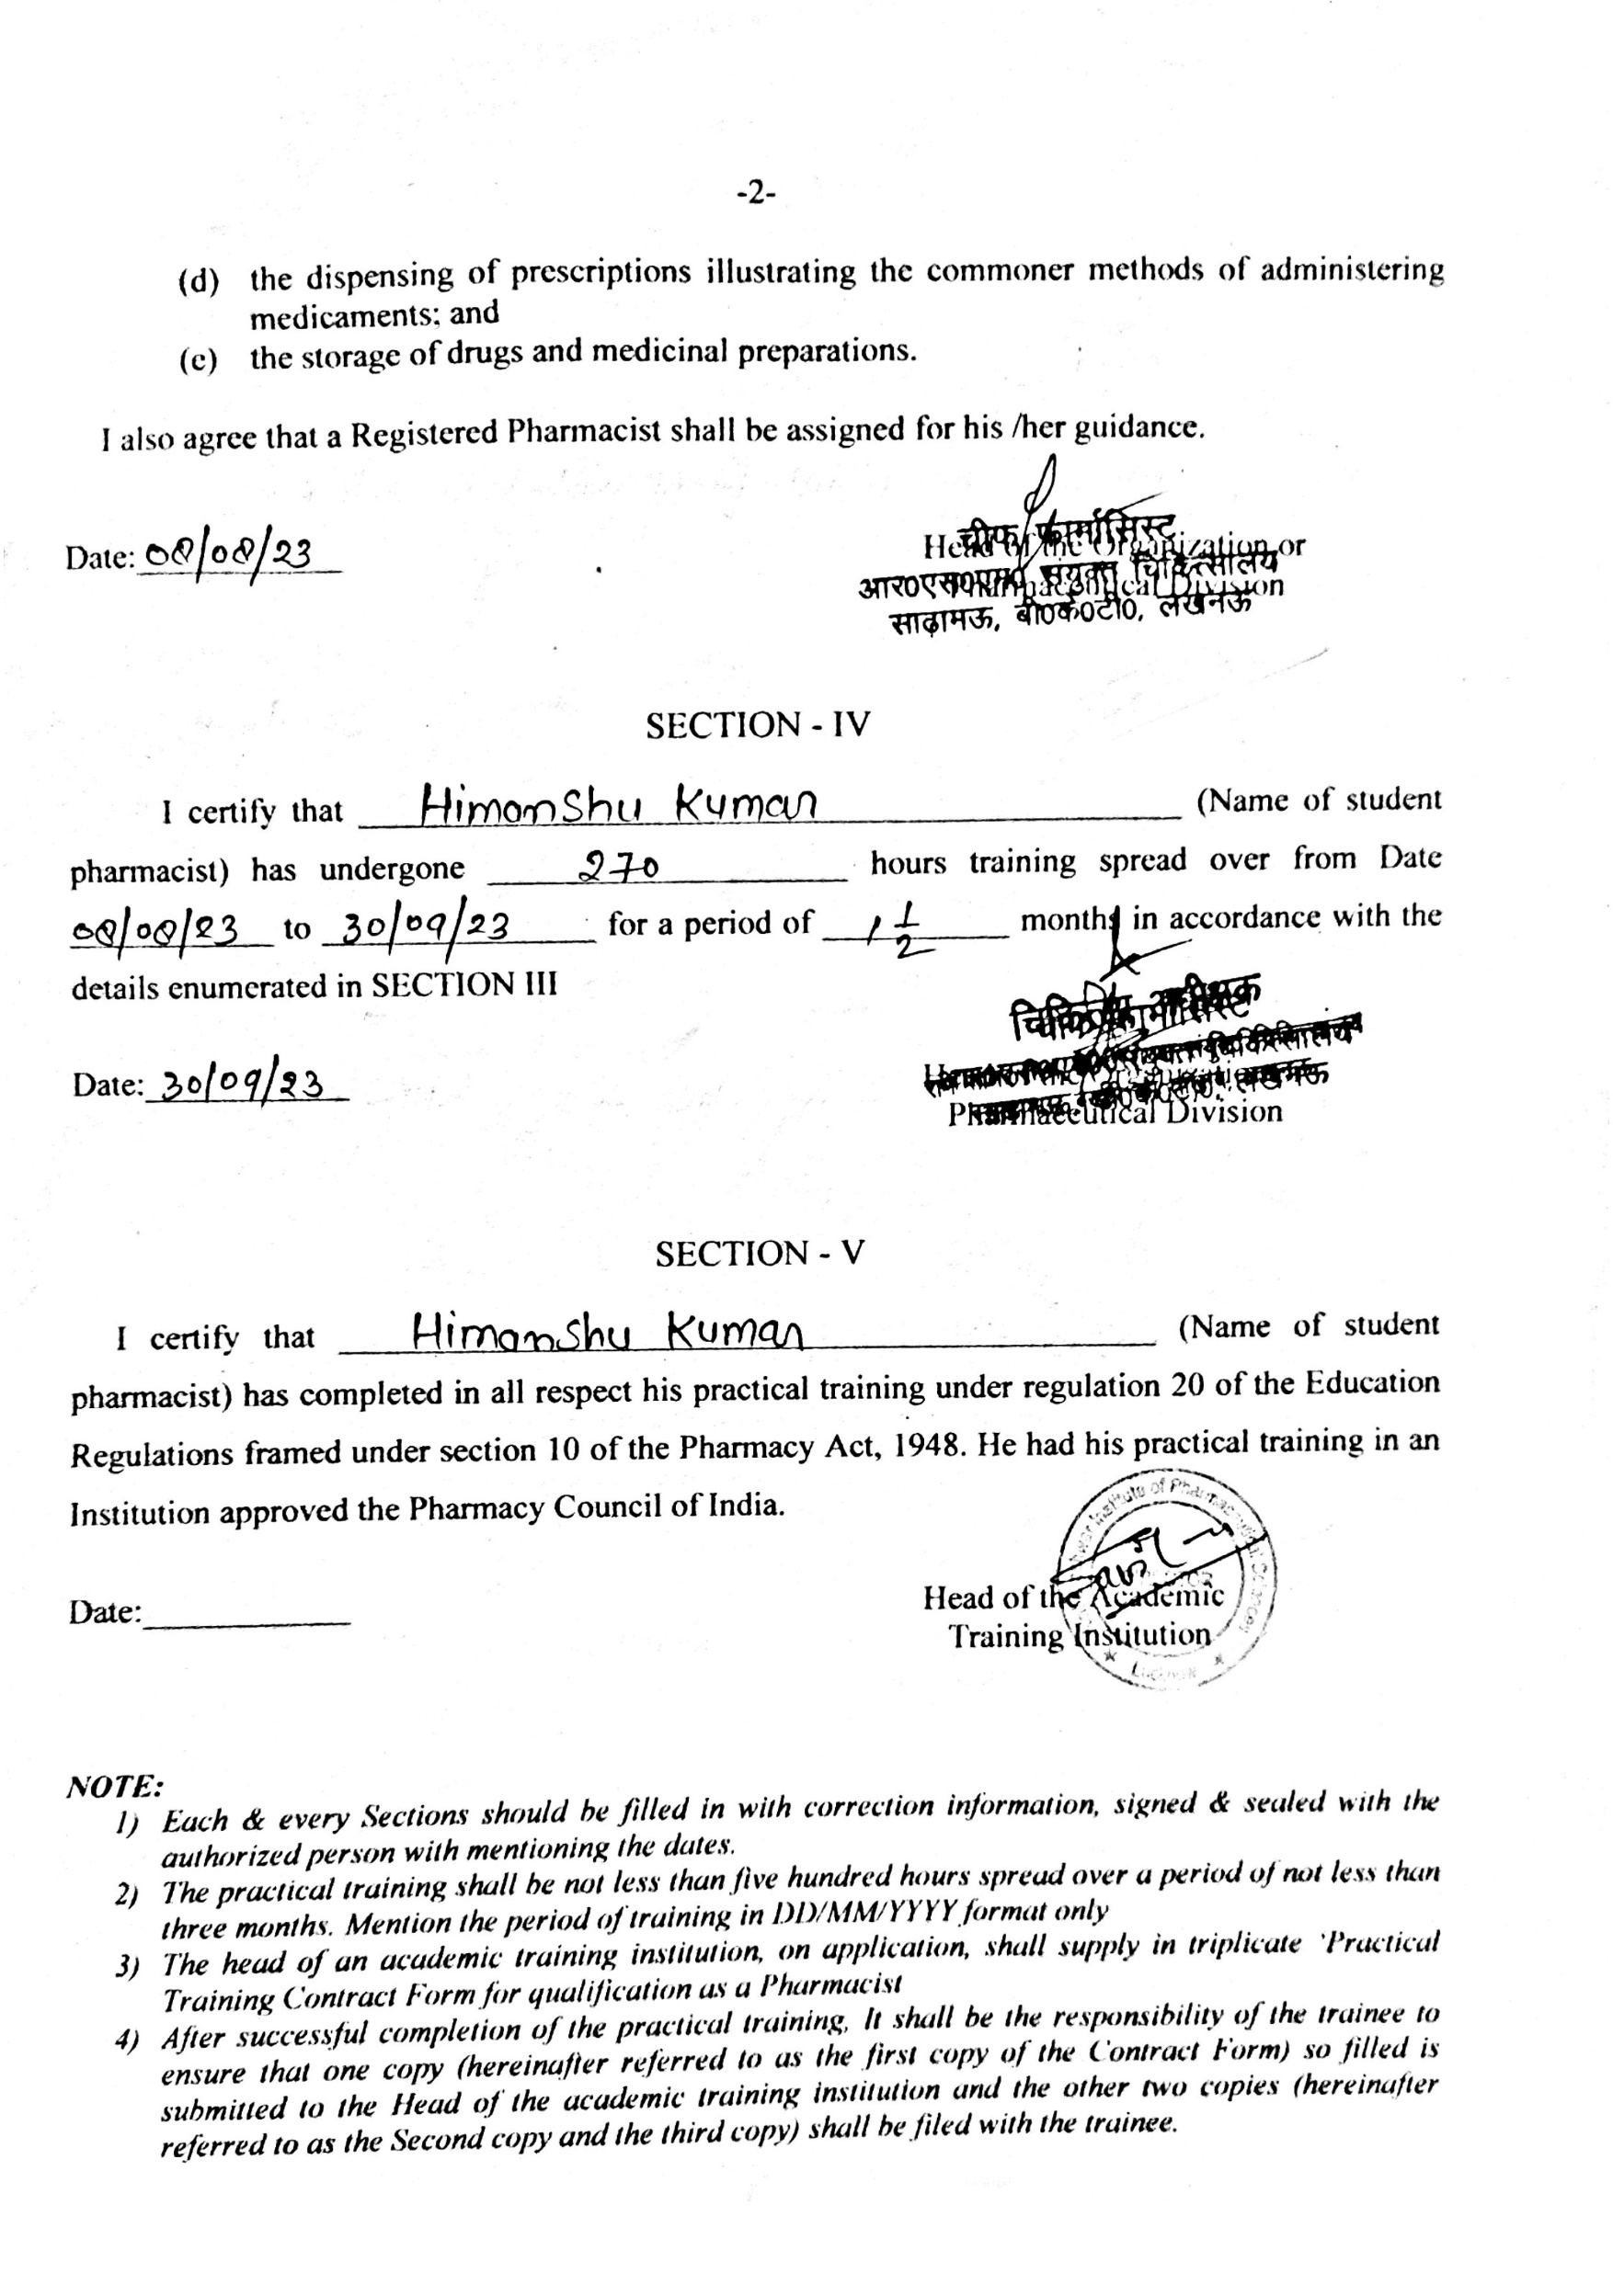

CONTENTS

S. No | Particulars | Page No.
1. | Certificate of Compilation | ii
2. | Copyright | iii
3. | Declaration by the Candidate | iv
4. | Certificate by the Co-Supervisor | v
5. | Certificate by the Supervisor | vi
6. | Acknowledgement | vii
7. | List of Tables | viii
8. | List of Figures | ix
9. | List of Abbreviation | x
10. | Practical Training Contract Form for Pharmacists | xi-xii
11. | Introduction | 1
12. | Hospital Profile | 2
13. | Training Imparted | 3-16
14. | Observation | 17
15. | Result and Discussion | 18
16. | Conclusion | 19
17. | Bibliography | 20

Introduction

INTRODUCTION
Hospitals are the institution providing medical and surgical treatment and nursing care for any ill or injured people.
It is an integral part of social and medical organization, the function of which is to provide complete health care to the needy one, both curative and preventive. it is also a center for providing training to health workers and center for biosocial research (WHO).
To better serve the wide-ranging needs of the community, the modern hospital has often developed outpatient facilities, as well as emergency, psychiatric, and rehabilitation services. In addition, “bed less hospitals” provide strictly ambulatory (outpatient) care and day surgery. Patients arrive at the facility for short appointments. They may also stay for treatment in surgical or medical units for part of a day or for a full day, after which they are discharged for follow-up by a primary care health provider.
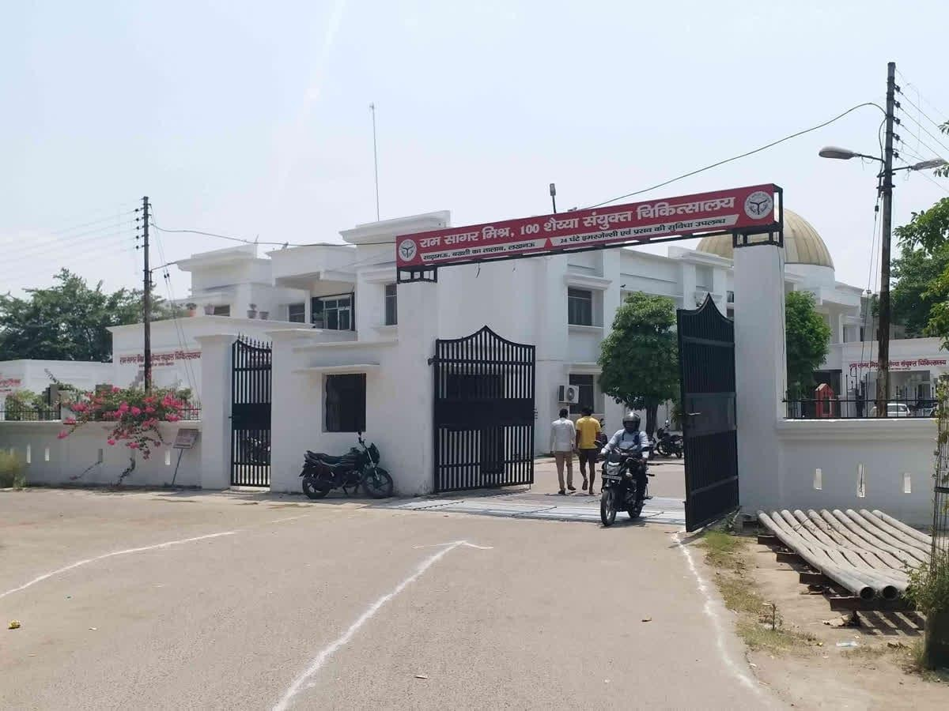
Figure no.1-Hospital

Hospital Profile

HOSPITAL PROFILE
A hospital contains one or more wards that house hospital beds for inpatients. It may also have acute services such as an emergency department, operating theatre, and intensive care unit, as well as a range of medical specialty departments. A well-equipped hospital may be classified as a trauma center. They may also have other services such as a hospital pharmacy, radiology, pathology, and medical laboratories. Some hospitals have outpatient departments such as behavioral health services, dentistry, and rehabilitation services.
- A hospital may also have a department of nursing, headed by a chief nursing officer or director of nursing. This department is responsible for the administration of professional nursing practice, research, and policy for the hospital.
- Many units have both a nursing and a medical director that serve as administrators for their respective disciplines within that unit. For example, within an intensive care nursery, a medical director is responsible for physicians and medical care, while the nursing manager is responsible for all the nurses and nursing care.
- Support units may include a medical records department, release of information department, technical support, clinical engineering, facilities management, plant operations, dining services, and security departments.

Hospital service
Hospital Services refers to the clinical services provided by the Hospital, as well as the operational activities that support those clinical services, which are funded in whole or in part by the LHIN, and includes the type, volume, frequency, and availability of Hospital Services; HSAA Indicator Technical Specifications refers to the document titled "HSAA Indicator Technical Specifications," as amended or replaced from time to time.
Hospital services are the foundation of a hospital's services. They are frequently influenced by the demands or wishes of the hospital's key users, with the goal of making the hospital a one-stop or core institution of the local community or medical network. Hospitals are facilities with basic services and personnel—usually medicine and surgical departments— that provide clinical and other services for specific diseases and ailments, as well as emergency care.

Department of hospital
- OPD
- Emergency wards
- General wards
- Surgical wards
- ICU
- Injection room
- Pathology
- Dispensing
- Operation theatre
- Blood bank

EMERGENCY WARD
Emergency department (ED) preparedness means that the Emergency Departmentmust have the staff and resources to evaluate all persons presenting to the ED.
- However, when it comes to pediatric patients, this is not always the case. A national survey concluded that only 10% of U.S. hospitals have a pediatric intensive care unit, 25% of hospitals without a pediatric trauma service admit critically injured children, and 7% of hospitals without a pediatric ward admit children.
- A Canadian study of ED preparedness demonstrated deficiencies in equipment needed to resuscitate a critically ill pediatric patient.
- Not all children are, or need to be, seen in a pediatric ED. In fact, of the approximately 35 million pediatric ED visits per year, only 10% seek care initially in a children's hospital/pediatric ED. What this means is that the other 31.5 million children seek care in general and community EDs, which have varying abilities to care for them. In most community EDs, pediatric patients account for 20% to 35%of the patient visits.
- This chapter reviews the issues involved in preparedness, possible solutions, suggested policies and procedures, and additional information that may prove beneficial to create an ED appropriately prepared for infants, children, and adolescents.

Prevent further harm
Also, some time called prevent the condition from worsening are danger of further injury this covers both external factors such as moving patients away from any cause of harm, and

applying first aid techniques to prevents worsening of the condition such as applying pressure to stop a bleed becoming dangerous
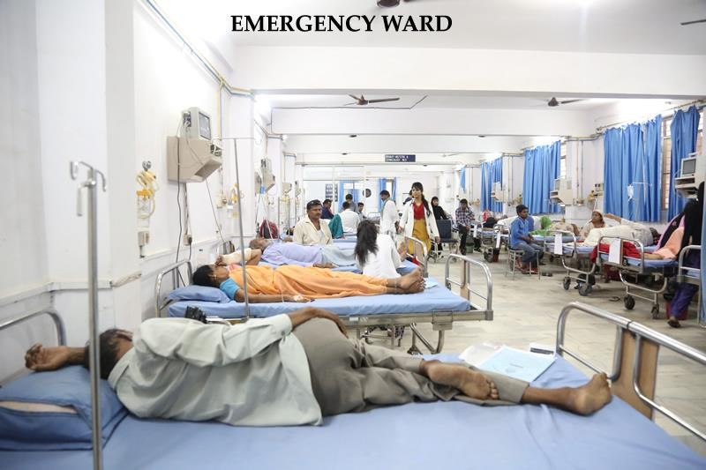

Figure no.2-Emergency room

Preserving Life
In to stay alive all persons need to have an open Airways clear where air can move in through the mouth or nose into the lungs without obstruction conscious people will maintain their own Airways automatically but those who are unconscious with agas of less than 8 may be unable to maintain a patient Airway as the part of the brain which automatically controls breathing in a normal situation.
Airway may not be functioning if the patients were breathing of first order would normally then place them in the recovery position with the patient’s length over on the other side which also has the effect of clearing the term from the next it also provides a common cause of death in unconscious patients which is choking on regular catered stomach.

Promoting Recovery
The first order is also likely to be trained in dealing with injuries such as God's grace or bone fracture they may be able to deal with the situation in it and early small ADC bandage on the

paper cut and may be required to maintaining the condition of something like a broken bone until the next stage of definitive C are usually and ambulance arrives.

Condition that often require first aid

Medical Emergency
- Altitude sickness which can being in susceptible people at attitude as lower 5,000 feet can cause patiently portal veiling of the brain or lungs
- Anaphylaxis for life threatening conditions in which the Airway can become constructed and the patient may go into such the reaction can be caused by a sin in termed allergic reaction to allergens such as insect bites or peanut enough anaphylaxis in initially treated with injection.
- Bone fracture of break in a bone initially created by establishing the fracture with
- Burns which can result in damage to tissue and loss of body Fluids through the burn sits
- Cardiac arrest which will lead to death unless CPR for will be combined with an aid is started wearing minute there is octane no times to wait for the emergency services to arrive as 92% of people suffering a sudden cardiac arrest die before reaching Hospital according to the American heart Associations.
- Choking blockage of the Airway which can quickly result in a death due to lack of oxygen if the patients treacher is not clear for example by the family man wear Heart Attack and inadequate blood flow to the blood vessels supplying the heart muscles
- Heat stroke also known as sunstroke or hyperthermia which tends to occurs during heavy exercise in higher Unity or with indicate water through it may occur spontaneously in some chronically ill person sunstroke especially when the victim has been unconscious of 10 causes major damage to body symptoms such as brain kidney liver gastric tracks unconscious for morethan 24 hours the usually leads to permanent disability.

GENERAL WARD
A general ward is a large room in hospital where people who need medical treatment state general wards. in general ward patient receive basic treatment facilities and medication with different route of administration such as oral, iv bolus , iv infusion etc.
Intravenous simple mean with vein therapist administered intra venous, the intravenously are often included in the design nation of specialty drug.
Intravenous infusions are commonly referred to as drips because many system administration

employees to a drip which prevent air from interfering the blood stream and allows as estimation are flow rate.
Intravenous may be used to correct electrolyte imbalances to deliver medication for blood transfusion is a fluid replacement to correct. For example, used in dehydration intravenous.
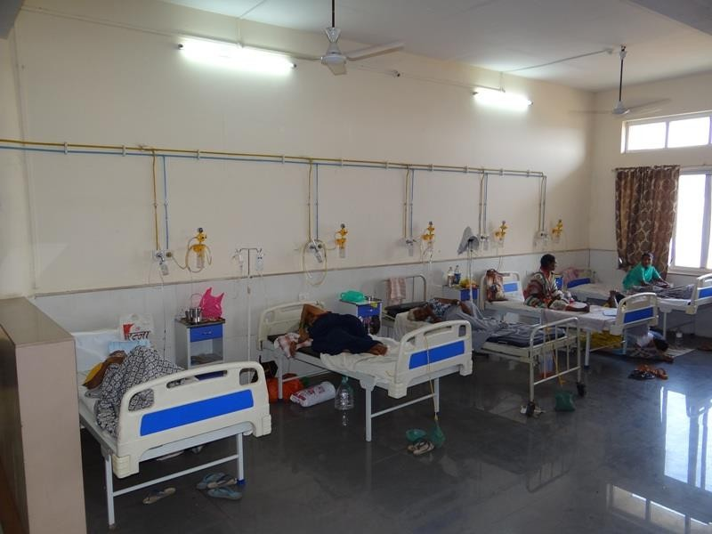

Figure no.3-General ward

INJECTION ROOM
Injection room is a medically supervised place where people can inject the drugs of dependence in a supervised health setting. It can also provide a gateway for people who inject drugs to access other health and social support services, including pathways to drugs treatment and rehabilitation.
An injection necessarily causes a small puncture wound to the body, and thus may cause localized pain or infection.

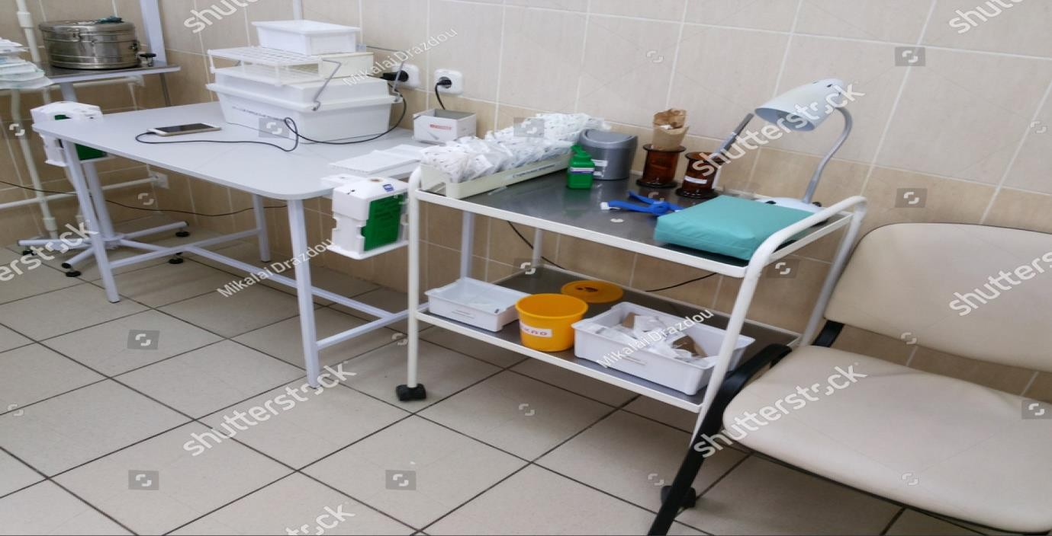
Figure no.4-Injection room
Injections are classified in multiple ways, including the type of tissues being injected into the location in the body to produce effects, and duration of effects.

Intravascular
Intravenous injections, abbreviated as IV, involve inserting a needle into a vein, allowing a substance to be delivered directly into the bloodstream. An intravenous injection provides the quickest onset of the desired effects because the substance immediately enters the blood, and is quickly circulated to the rest of the body. Because the substance is administered directly into the bloodstream, there is no delay in the onset of effects due to the absorption of the substance into the bloodstream. This type of injection is the most common and is used frequently for administration of medications in an inpatient setting.

Intramuscular
Intramuscular injections, deliver a substance deep into a muscle, where they are quickly absorbed by the blood vessels into systemic circulation. Common injection sites include the deltoid, vastus lateralis, and ventrogluteal muscles. Medical professionals are trained to give IM injections, but people who are not medical professionals can also be trained to administer medications like epinephrine using an autoinjector in an emergency.^{[10]} Some depot injections are also administered intramuscularly, including medroxyprogesterone

acetate among others.^{[11]} In addition to medications, most inactivated vaccines, including the influenza vaccine, are given as an IM injection.

Subcutaneous route
The drug is dissolved in a small volume of vehicle and injected beneath the skin from where the absorption is slow and uniform. The substances causing irritating to the tissues should not be injected otherwise they will cause pain and necrosis de detaining of tissues at the site of injection.
This method is particularly useful when continuous presence of the drug is the tissue is needed over a long period the usefulness of this method is enhanced by the cause of the report preparation from which the drug is released more slowly than its from simple solution doses, example insulin.

Intradermal route
Intradermal injections, abbreviated as ID, consist of a substance delivered into the dermis, the layer of skin above the subcutaneous fat layer, but below the epidermis or top layer. An intradermal injection is administered with the needle placed almost flat against the skin, at a 5 to 15-degree angle. Absorption from an intradermal injection takes longer than when the injection is given intravenously, intramuscularly, or subcutaneously. For this reason, few medications are administered intradermally. Intradermal injections are most commonly used for sensitivity tests, including tuberculin skin tests and allergy tests, as well as sensitivity tests to medications a person has never had before. The reactions caused by tests which use intradermal injection are more easily seen due to the location of the injection, and when positive will present as a red or swollen area. Common sites of intradermal injections include the forearm and lower back.

Intraperitoneal route
The peritoneum offers a large absorbing surface area from which drugs in circulation rapidly but primarily by our way of portal vein.
Hence first pass effect not divided this is probably the most widely used route of drug administration in laboratory animals in human.
It is very rarely employer due to the dangerous of infection and injury to risk area and blood vessels example peritoneal dialysis in case of renal insufficiency.

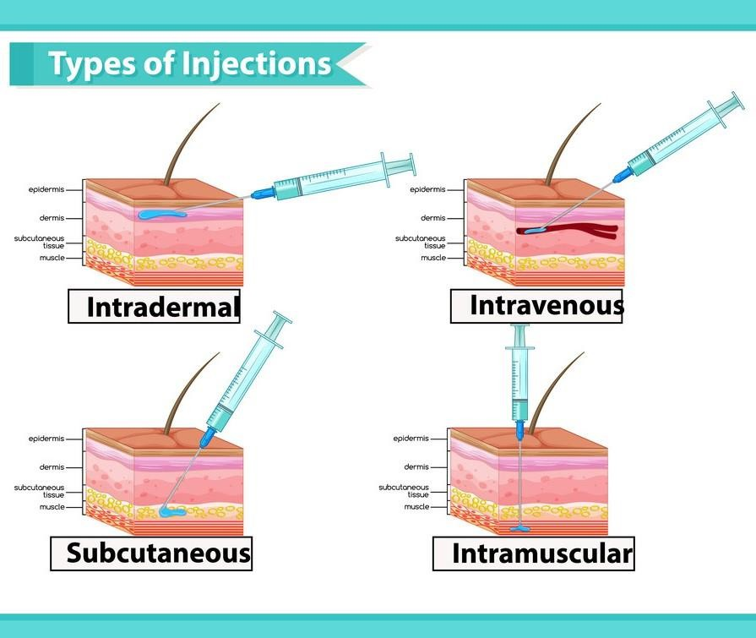
Figure no.5–Types of injection

PATHOLOGY
Pathology is a branch of medical science primarily concerning the cause, origin and nature of disease. It involves the examination of tissues, organs, bodily fluids and autopsies in order to study and diagnose disease.
Currently, pathology can be divided into different areas, depending on the types of methods used or the types of diseases examined. These different disciplines are described below.

General pathology
- General pathology describes a complex and broad field that involves the study of the mechanisms behind cell and tissue injury, as well as understanding how the body responds to and repairs injury. Examples of areas that may be studied include necrosis, neoplasia, wound healing, inflammation and how cells adapt to injury.
- Thorough understanding in these areas is applied in the diagnosis of disease. General pathology is also the term used to describe anatomical and clinical pathology.
- This field covers areas of pathology, but at a less specialist level. A person working in general pathology would be trained in the areas of laboratory analysis, such as hematology

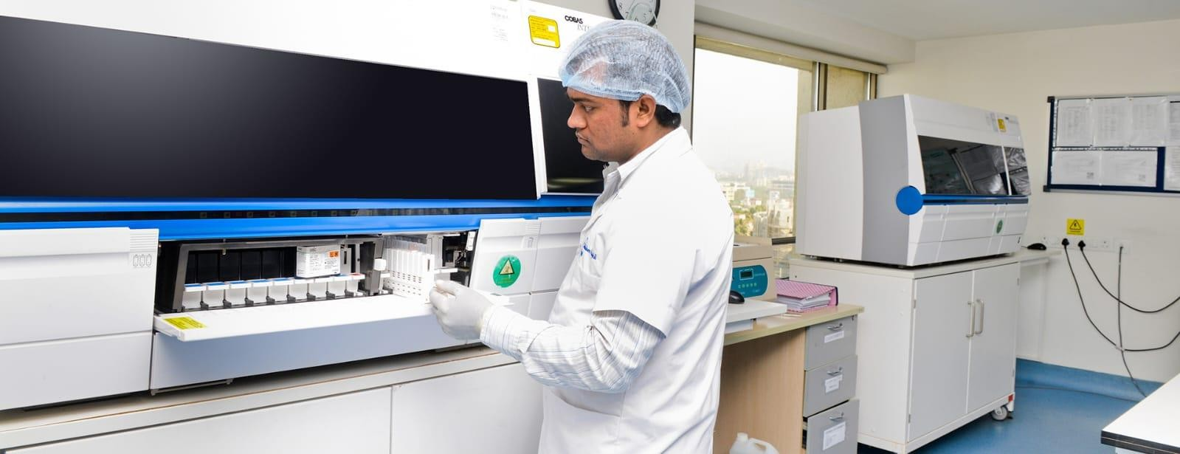

Figure no.6-Pathology

Anatomical pathology
This field is concerned with the study and diagnosis of illness through microscopic analysis of samples from bodily fluids, tissues organs and sometimes the entire body or autopsy. Factors that may be examined include the cell appearance, anatomical make up and chemical signatures within cells.
This discipline can be subdivided into several disciplines and examples of these are given below:
- In histology, samples of bodily tissues and organs are prepared and examined in order to detect and diagnose disease. The architecture of tissue is observed at a microscopic level and the relationship between different cell and tissue types is examined.
- In cytology, the bodily fluids and tissues are examined at the cellular level in order to screen for and diagnose disease and help aid treatment decisions. A cytologist will examine how cells look, form and function.
- Forensic pathology is the examination of an autopsy in order to discover the cause of death. The external appearance is first assessed to check for evidence of wounds or suffocation, for example, surgical procedures are then begun and the internal organs are studied to see whether internal injuries exist and are connected to external ones.

Blood test abbreviations
Blood test results generally use the metric system of measurement and various abbreviations,including
- cmm: cells per cubic millimeter
- fL (femtoliter): fraction of one-millionth of a liter
- g/dL: grams per deciliter
- IU/L: international units per liter
- mEq/L: milliequivalent per liter
- mg/dL: milligrams per deciliter
- mL: milliliter
- mmol/L: mill moles per litre
- ng/mL: nanograms per milliliter
- pg (picograms): one-trillionth of a gram

Complete blood count (CBC)
  - The complete blood count (CBC) is one of the most commonly ordered blood tests. The complete blood count is the calculation of the cellular (formed elements) of blood. Special machines that analyze the different components of blood in less than a minute generally determine these calculations.
  - A major portion of the complete blood count is the measure of the concentration of white blood cells, red blood cells, and platelets in the blood.

WBC (White blood cell)
A type of blood cell that is made in the bone marrow and found in the blood and lymph tissue. White blood cells are part of the bodies immune system. They help the body fight infection and other diseases.

Types of white blood cells are
Granulocytes (Neutrophils, eosinophils, and basophiles), monocots, and lymphocytes (T cells and B cells). Checking the number of white blood cells in the blood is usually part of a complete blood cell (CBC) test. It may be used to look for conditions such as infection,

inflammation, allergies, and leukemia. Also called leukocyte and WBC.

Table no.1-NORMAL WBCS (WHITE BLOOD CELLS) DISTRIBUTION

White blood cell line | Normal percentage of totalleukocyte count
Neutrophils | 40-60
Lymphocytes | 20-40
Monocytes | 2-8
Eosinophils | 1-4
Basophils | 0.5-1

RBC (Red Blood Cell)
Red blood cells are round with a flattish, indented center, like doughnuts without a hole. Your healthcare provider can check on the size, shape, and health of your red blood cells using a blood test.

What is this test?
This test measures the number of red blood cells, or erythrocytes, in your blood. Red blood cells play a critical role in moving oxygen from your lungs to the rest of your body and returning carbon dioxide to your lungs to be exhaled.
A red blood cell (RBC) count is typically done as part of a complete blood count. This is a screening test to check for a variety of medical conditions.

Why do I need this test?
You may need this test if you have symptoms such as weakness or tiredness during a general checkup. You may also have this test to look for specific health problems, such as internal bleeding, anemia, kidney disease, and certain cancers.
You may also need this test if your healthcare provider wants to watch any of these health problems. Your healthcare provider may also want this test done to determine if your RBC count is too high.

What other tests might I have along with this test?
A red blood cell count is often part of a complete blood count (CBC). This means that other components of your blood are also measured. These include white blood cells, hemoglobin level, and platelets.
If your healthcare provider suspects you have a particular illness, they may also order other tests needed for making a diagnosis.

What do my test results mean?
Test results may vary depending on your age, gender, health history, the method used for the test, and other things. Your test results may not mean you have a problem. Ask your healthcare provider what your test results mean for you.
An RBC count is measured in millions per cubic millimeter (million/mm3). Normal values may vary slightly among different labs. One example of normal values is:
- 4.1 to 5.1 million/mm3 for women
- 4.5 to 5.9 million/mm3 for men

DIAGNOSTIC REPORT
A diagnostic report is the set of information that is typically provided by a diagnostic service when investigations are complete. The information includes a mix of atomic results, text reports, images, and codes. The mix varies depending on the nature of the diagnostic procedure, and sometimes on the nature of the outcomes for a particular investigation. In FHIR, the report can be conveyed in a variety of ways including a Document, Restful API, or Messaging framework. Included within each of these, would be the Diagnostic Report resource itself.
The Diagnostic Report resource has information about the diagnostic report itself, and about the subject and, in the case of laboratory tests, the specimen of the Report. It can also refer to the request details and atomic observations details or image instances. Report conclusions can be expressed as a simple text blob, structured coded data or as an attached fully formatted report such as a PDF.
The Diagnostic Report resource is suitable for the following kinds of diagnostic reports:
- Laboratory (Clinical Chemistry, Hematology, Microbiology, etc.)
- Pathology / Histopathology / related disciplines
- Imaging Investigations (x-ray, CT, MRI etc.)

- Other diagnostics - Cardiology, Gastroenterology etc.
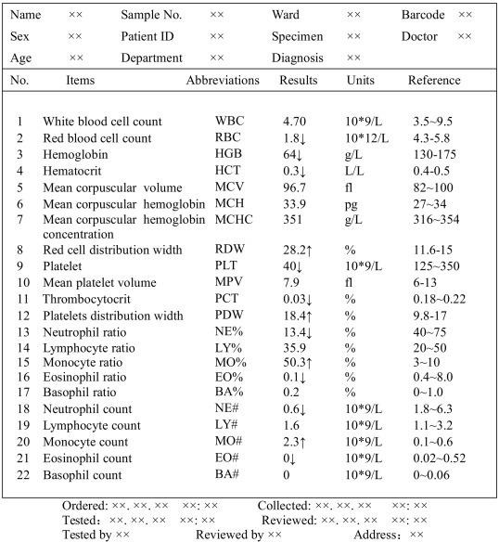

Figure no.7–Diagnostic report

DRUGS DISPENSING
Drug distribution room is a department within a hospital that prepares, compounds, stocks, dispenses inpatient medication. Drug distribution usually stock a larger range of medications, including more specialized and investigational medications than would be feasible in the community setting. It can also dispense over the counter and prescription medications to outpatients. It may provide a huge quantity of medications per day which is allocated to the wards and to intensive care units according to the patient’s medication schedule. Larger hospital may use automated transport systems to aid in the efficient distributions of medications. In drug distribution room many varieties of drugs are present which are helpful in the treatment of poor people.

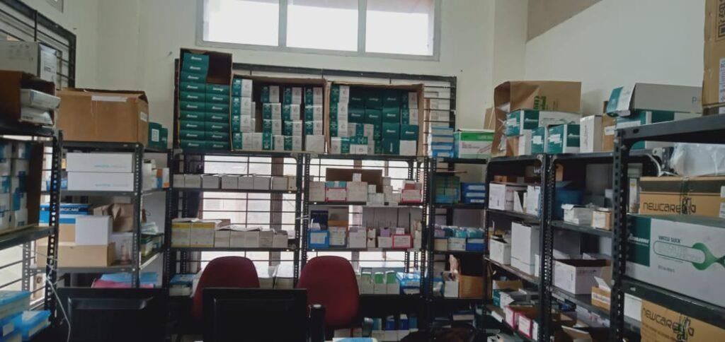
Dispensing is an important part of the practice of pharmacy, in which the pharmacist or the pharmacy technician (under the direct supervision of the pharmacist) interprets the physician's requirements on the prescription and accordingly supplies medicines for the treatment of his patient (s). This usually involves interpreting a written prescription but may,on occasions, also include taking in restrictions given by word of mouth or by telephone from the physician.

Figure no.8-Dispensary Dispensing prescriptions on part payment
Where a patient does not have enough money to pay for all the drugs as prescribed, the dispenser is faced with a difficult situation. Consider the following scenario to resolve this situation.
  - Cotrimoxazole 400/80 mg tab 2 bd × 5 days
  - Chloroquine 150 mg tab 4 stat, then 2-tab bd × 2/7
  - Either dispenses all the 20 tablets of cotrimazole or the 10 tablets of chloroquine as prescribed and insists that the patient completes the dose dispensed.
  - In case a patient is unable to pay for all the prescribed drugs, go to the prescriber and ask which of the two drugs should be dispensed first.
  - Do not dispense a few tablets of cotrimoxazole and a few tablets of chloroquine as the patient will not come back to complete the prescription if he feels better.
  - When the temporary relief passes, the cotrimaoxazole or chloroquine may not be effective again in that particular condition.

Table no.2- LIST OF MEDICINES

S.no. | Name of the drug
1 | Lignocaine topical form
2 | Diclofenac tablets 50 mg
3 | Ibuprofen tablet 50mg
4 | Paracetamol 50 mg
5 | Levocetrizine 5 mg tablet
6 | Magnesium sulfate injection (50% solution)
7 | Amoxicillin capsule 250mg

OBSERVATION

During 45 days of hospital training, I observed that hospital is an institution which consists of medical staff and equipment for the diagnostic and treatment purpose for the ailment of disease. Hospital also has a department of nursing, headed by a chief nursing officer or director of nursing. This department is responsible for the administration of professional nursing practice, research, and policy for the hospital.
In hospital the doctors, nurses and other staff unit together to provide better management and serves administration for their respective medicines, such as medical director manages physicians and nursing manager responsible for management of nursing staff.
The medicine room that provide a better storage condition for the medicine and the pharmacy staff provide adequate dispensing of medicine. The medical record department, technical department, clinical department, facility management unite to support healthy environment of hospital.

RESULTS & DISCUSSION

The hospital provide requirements of storage of information of every patients records. That consists of diagnostic reports, prescription details diet advice and record of medicines to be dispensed, family history etc. It provides all the emergency services to the patients with in minimum time. It manages out-patient and in-patient department. It provides effective treatment to the patient without any discrimination and professional counsellers are also available for to communicate to the people whenever required. They used to follow steps to prevent further harm, preserving life and promote recovery of the patients. They also tackle medical emergency situation. The general ward provides prevention and cure to the inpatient where they provided with proper medical facilities. Those patients who are not able to understand medical technical words are generously handled and explained in a simple way.

CONCLUSION

The 45 days training was a very fruitful experience for me. It helped me to enhance my knowledge regarding the various diseases and their treatment. It gives detailed knowledge about the medicines, which is used in the hospital.
The hospital training demonstrate that the district hospital is an essential part of health care society that provide cheapest and effective medical services to the patients that are not able to afford expensive medical services. The hospital provides general examination, diagnosis of disease, medication facilities, emergency services etc. They provide preventive and primary care to the inpatient and also provides surgical facility.
The final conclusion of hospital report is that the hospital provide prevention from further harm, preserve life of individual, and also promote recovery from the diseased condition.

BIBLIOGRAPHY

- https://en.wikipedia.org/wiki/Hospital
- https://en.wikipedia.org/wiki/Emergency_department
- https://www.medifee.com/hospitals/general-ward/ -
:~:text=General%20ward%20is%20a%20common,comfort%20and%20other%20essential%2 0factors.
- https://hospital.dypatilmedicalkop.org/infrastructure/indoor-ward/
- https://www.medicalnewstoday.com/articles/types-of-injections
- https://www.ncbi.nlm.nih.gov/pmc/articles/PMC7150046/
- https://en.wikipedia.org/wiki/Dispensary -
:~:text=A%20dispensary%20is%20an%20office,even%20medical%20and%20dental%20trea tment.
- https://en.wikipedia.org/wiki/Pathology

